Exercises 5

(1) The following assignments are just for your reference.
1 A is a 2-D symmetric array（二维对称矩阵）, to save the storage space, we just store the upper triangular element, try to deduct the addressing formula.
2 We have three arrays A[n+1], B[n+1][m], C[n+1][n+2], how many elements can these arrays have separately?
3 A 3-D array A[2][3][4]（三维矩阵）, suppose that the length of each array element is 4 Bytes，please calculate the relative address of A_{2, 3, 2}.
4 Suppose A is a upper triangular matrix（上三角矩阵）with n rows and n columns. Store its non-zero elements to an 1-D array b[1…n(n+2)/2] in column order, and b[1] stores a_{1,1}, write the addressing formula of a_{i, j}.
5 A given n-D array a[l₁…u₁, l₂…u₂, …, l_{n}…u_{n}], if the storage address of a[l₁,l₂,…,l_{n}] is α, give the storage address of a[i₁, i₂, …, i_{n}].
6 Do HEAD operation and TAIL operation on the generalized list LS=(a, ((b, c), (), d), ((e))), and give its storage structure.
7 Give the logic structure of the generalized list according its storage structure shown in the following Fig.1
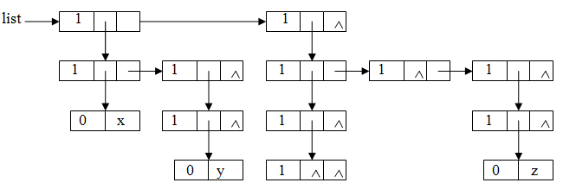
Fig. 1
8设有稀疏矩阵B如下图所示，请画出该稀疏矩阵的三元组表和十字链表存储结构。
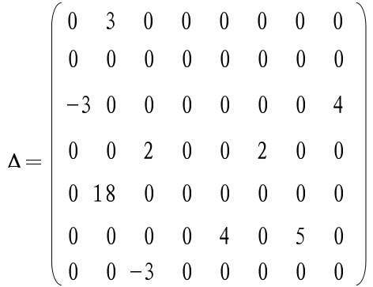

(2) The following assignments must be submitted by you.
1 An element a[i][j] of a m×n matrix satisfies the following conditions: a[i][j] is both the minimum of ith row and the maximum of jth column. Try to write an algorithm to find such the element a[i][j] in an array, and analysis the time complexity of your algorithm.

2设A和B是稀疏矩阵，都以三元组作为存储结构，请写出矩阵相加的算法，其结果存放在三元组表C中，并分析你的算法时间复杂度。

